

|  |  |  |  |  |  |  |  |  |  |  |  |
| --- | --- | --- | --- | --- | --- | --- | --- | --- | --- | --- | --- |
| |  |  | | --- | --- | | Contact | Glennda Moragne El | | Telephone | 410.872.9632 | | Cell | 410.804.7550 | | Email | moragneelg@qlarant.com | | Website | www.qlarant.com | | FOR IMMEDIATE RELEASEJuly 15, 2020 |

Qlarant Hosts Virtual grant awards event

$340k in Grants Given to Maryland and D.C. Non-Profit Organizations

July 15, 2020, Easton, MD – Qlarant Foundation, the philanthropic arm of Qlarant, the nationally recognized program integrity and quality company, has awarded financial grants to sixteen Maryland and District of Columbia organizations. Members of the Board of Directors for Qlarant Foundation held a virtual reception for the 2020 Grant Awards.

In an average year, Qlarant holds their annual awards ceremony in their Easton, Maryland headquarters. In the current environment, hosting a physical reception for the grantees was not a viable option. A virtual reception was planned instead.

“We were challenged by circumstance to create a virtual event for our grantees and board members to attend online,” said Dr. Molly Burgoyne-Brian, Board Chair for Qlarant Foundation. “Aside from the grant itself, the networking opportunity that our annual event provides is often mentioned by our grantees as being one of the best parts of our program. By going fully online, we were able to have multiple representatives from each organization participate and join in discussions to share information. We’ve now given over $5.5 million dollars to organizations like these since 2007.”

The 2020 grant recipients include returning organizations: Breast Care for Washington, D.C., Calvary Women’s Services, Camp Attaway, Deep Roots, Eastern Shore Wellness Solutions, Girls in the Game, Grace Center for Maternal and Women’s Health, Helping Up Mission, Miriam’s Kitchen, Shepherd’s Clinic, University Legal Services Jail and Prison Advocacy Project, and University of Maryland Medical Center’s Breathmobile. All of these organizations are dedicated to providing health and human services to underserved populations. First time grantees included Bay Hundred Community Volunteers, Mid-Shore Pro Bono, Talbot County Empty Bowls, and the Ulman Foundation. Over 50 representatives from across all of the organizations attended virtually.

During the event, each of the grantees were highlighted in a pre-produced video segment (available on Qlarant’s website) and given the opportunity to present a brief summary of their organizations’ work. They also were asked to speak to some of the “unexpected positives” each non-profit has experienced while adjusting to COVID-19.

“At first it didn’t feel like there were any positives, but there have been positives,” said Sue Ann Shafley, Executive Director at Camp Attaway, a therapeutic program serving children ages 7-13 with complex emotional and behavioral disorders. “Because of COVID, we had to get really creative and we had to think, ‘How can we get kids to feel connected over the internet?’ So we decided we would do things like have pizza parties online and have pizza delivered to their homes and send tents to them so during camp they could get in their tents. Learning new platforms helps kids stay connected after camp is over.”

“Not everything about the quarantine has to be focused on what we can’t do,” said Deb Keller, Qlarant Vice President. “We encouraged our grantees to share some of the positives they’ve discovered while adapting to the ‘new normal’ for the benefit of the group. Part of our goals at Qlarant is to positively impact the community and this event was designed to further that goal.”

About Qlarant Foundation

Qlarant Foundation is the philanthropic arm of Qlarant, a not-for-profit nationally respected leader in fighting fraud, waste & abuse, improving program quality, and optimizing performance. The organization was founded more than 45 years ago to improve health care and human services for all. Qlarant Foundation is focused on reinvesting in our people and resources to better support our clients’ missions. [www.qlarant.com/about/qlarant-foundation](http://www.qlarant.com/about/qlarant-foundation)

If you would like more information about this topic, please contact Glennda Moragne El at 410.872.9632 or email at moragneelg@qlarant.com.

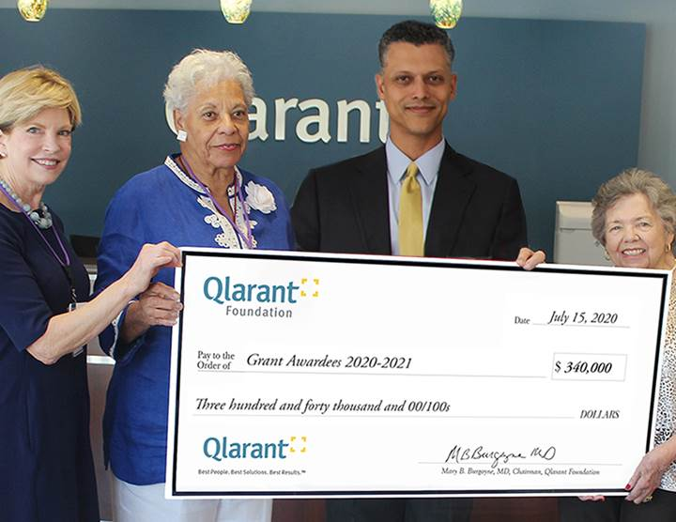

Qlarant Foundation presented $340k to sixteen non-profit organizations: (left to right) Qlarant Foundation Chair Molly Burgoyne-Brian, Qlarant Board Member Dr. Senora Simpson, Qlarant CEO Dr. Ron Forsythe, Jr., and Qlarant Foundation Secretary Brenda Crabbs.

